**Lab - Building a Simple Network**

# Hinweise zur Bearbeitung

* Die PCs im Raum 312 verfügen über zwei Netzwerkkarten (NIC). Für Laborarbeiten ist die Intel Ethernet I210-Karte (LAN-Verbindung *Ethernet*) zuständig und muss ggfs. durch Rechtsklick in den Netzwerkverbindungen aktiviert werden.  
  **Achtung**: Das Deaktivieren des anderen NIC (*Ethernet Connection 2*) oder die Trennung dieser Karte vom Netzwerk führt zur Trennung der Internetverbindung und der Verbindung zum lokalen Netzwerk (auch Laufwerk H:)
* Die Arbeitsgruppen benutzen jeweils zwei PCs, deren Nummer/Bezeichnung an der **roten Dose** Ihrer Arbeitsplätze abzulesen ist. Die Gruppenaufteilung ergibt sich automatisch durch den Arbeitsplatz. Die Gruppen verwenden die folgende IP-Adressen:

**PC-Namen IP-Adressen Gruppe**

* + PC1_1, PC1_2 192.168.1.1, 192.168.1.2 1
  + PC1_3, PC1_4 192.168.2.1, 192.168.2.2 2
  + PC1_5, PC1_6 192.168.3.1, 192.168.3.2 3
  + PC2_1, PC2_2 192.168.4.1, 192.168.4.2 4
  + PC2_3, PC2_4 192.168.5.1, 192.168.5.2 5
  + PC3_1, PC3_2 192.168.6.1, 192.168.6.2 6
  + PC3_3, PC3_4 192.168.7.1, 192.168.7.2 7
  + PC4_1, PC4_2 192.168.8.1, 192.168.8.2 8
  + PC4_3, PC4_4 192.168.9.1, 192.168.9.2 9
  + PC4_5, PC4_6 192.168.10.1, 192.168.10.2 10
* Die Switche befinden sich in den beiden Netzwerkschränken im vorderen Teil des Raumes. Die Tischreihen 1 und 2 benutzen dabei den linken, die Tischreihen 3 und 4 den rechten Schrank.
* Die NIC Ihres Arbeitsplatz-PC (rote Tischdose) wird zuerst mit der blauen Netzwerkdose verbunden, die Sie in den Verteilerschrank bringt. Von dort aus müssen Sie sich in geeigneter Weise mit dem Ihnen zugeordneten Netzwerkschrank verbinden.

# Topology

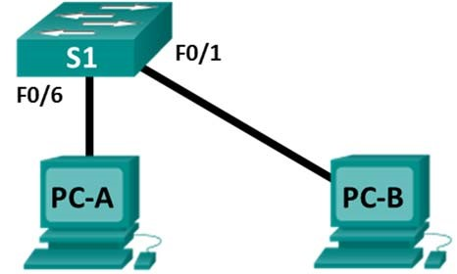

# Objectives

**Part 1: Set Up the Network Topology (Ethernet only)**



* Identify cables and ports for use in the network.
* Cable a physical lab topology.

**Part 2: Configure PC Hosts**

* Enter static IP address information on the LAN interface of the hosts.
* Verify that PCs can communicate using the **ping** utility.

# Background / Scenario

Networks are constructed of three major components: hosts, switches, and routers. In this lab, you will build a simple network with two hosts and a switch. You will apply IP addressing for this lab to the PCs to enable communication between these two devices. Use the **ping** utility to verify connectivity.

**Note**: The switches used are Cisco Catalyst 2960s with Cisco IOS Release 15.0(2) (lanbasek9 image). Other switches and Cisco IOS versions can be used.

# Required Resources

* 1 Switch (Cisco 2960 with Cisco IOS Release 15.0(2) lanbasek9 image or comparable)
* 2 PCs (Windows 10)
* Two Ethernet cables as shown in the topology

© 2016 Cisco and/or its affiliates. All rights reserved. This document is Cisco Public.

# Part 1: Set Up the Network Topology (Ethernet only)

In Part 1, you will cable the devices together according to the network topology.

**Step 1: Power on the devices.**

Power on all devices in the topology. The switches do not have a power switch; they will power on as soon as you plug in the power cord.

**Step 2: Connect the PCs to the switch.**

1. Connect one end of an Ethernet cable to the NIC port on PC-A. Connect the other end of the cable to F0/6 on S1. After connecting the PC to the switch, you should see the light for F0/6 turn amber and then green, indicating that PC-A has been connected correctly.
2. Connect one end of an Ethernet cable to the NIC port on PC-B. Connect the other end of the cable to F0/1 on S1. After connecting the PC to the switch, you should see the light for F0/1 turn amber and then green, indicating that the PC-B has been connected correctly.

**Step 3: Visually inspect network connections.**

After cabling the network devices, take a moment to carefully verify the connections to minimize the time required to troubleshoot network connectivity issues later.

# Part 2: Configure PC Hosts

**Step 1: Configure static IP address information on the PCs.**

1. To configure the Network Settings on PC-A, click **Start**, then click **Settings**.

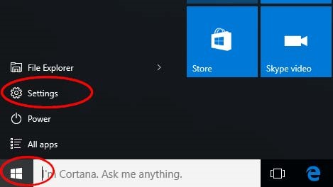

1. In the Settings window click **Network & Internet**.

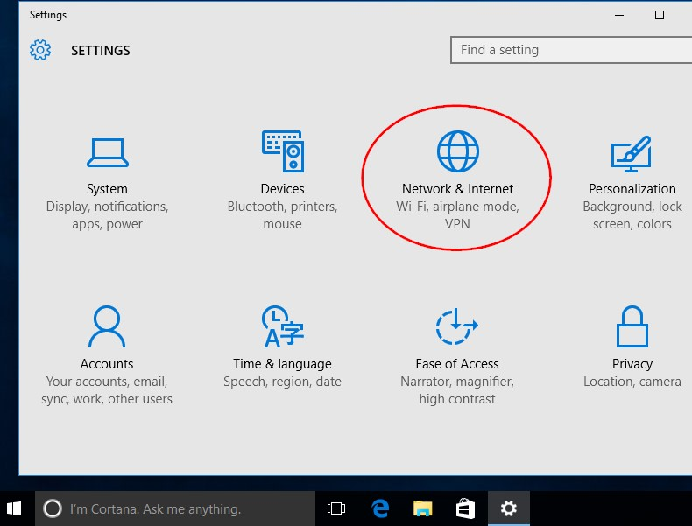

1. In the left pane select **Ethernet**, then click **Change adapter options**.

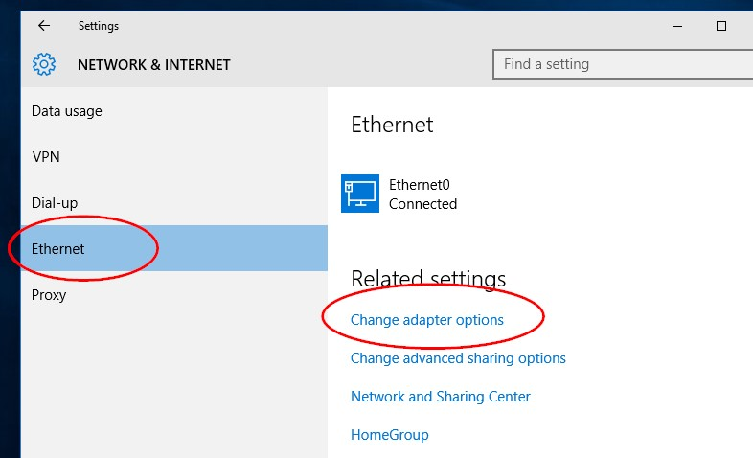

1. The Network Connections window displays the available network interfaces on the PC. Right-click the **Ethernet0** interface and select **Properties**.

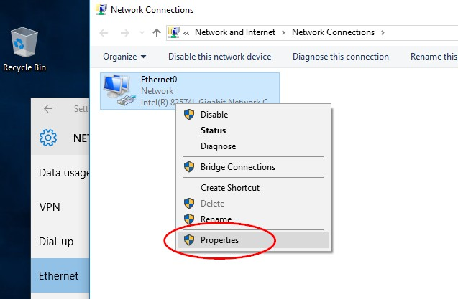

1. Select the **Internet Protocol Version 4 (TCP/IPv4)** option and then click **Properties**.

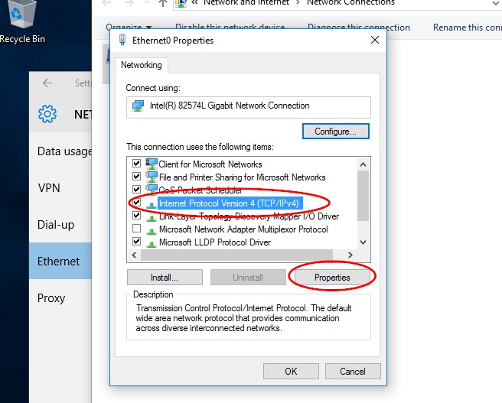

**Note**: You can also double-click **Internet Protocol Version 4 (TCP/IPv4**) to display the Properties window.

1. Click the **Use the following IP address** radio button to manually enter an IP address, subnet mask, and default gateway. Type in the IP address 192.168.1.10 and the subnet mask 255.255.25.0

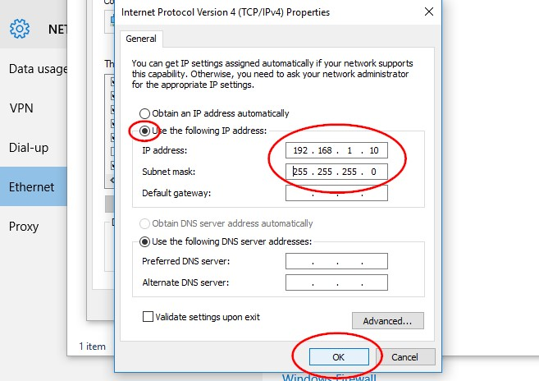

**Note**: In the above example, the IP address and subnet mask have been entered for PC-A. The default gateway has not been entered, because there is no router attached to the network. Refer to the Addressing Table on page 1 for PC-B’s IP address information.

1. After all the IP information has been entered, click **OK**. Click **OK** on the Ethernet0 properties window to assign the IP address to the LAN adapter.
2. Repeat the previous steps to enter the IP address information on PC-B.

**Step 2: Verify PC settings and connectivity.**

Use the Command Prompt to verify the PC settings and connectivity.

1. From PC-A, right-click **Start**, select **Command Prompt**.

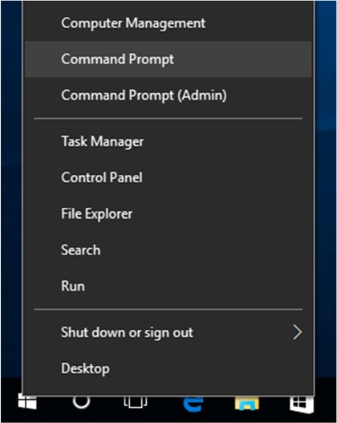

1. The cmd.exe window is where you can enter commands directly to the PC and view the results of those commands. Verify your PC settings by using the **ipconfig /all** command. This command displays the PC hostname and the IPv4 address information.

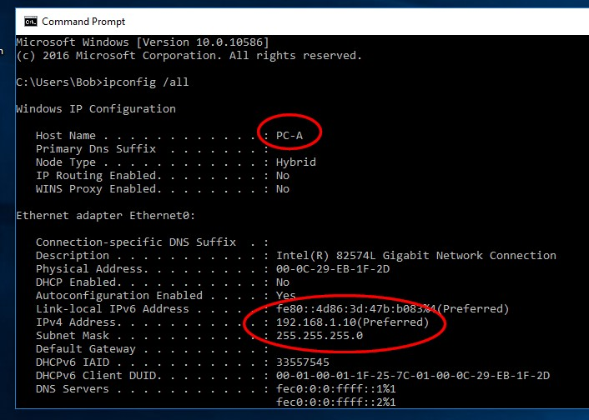

1. Type **ping 192.168.1.11** and press Enter.

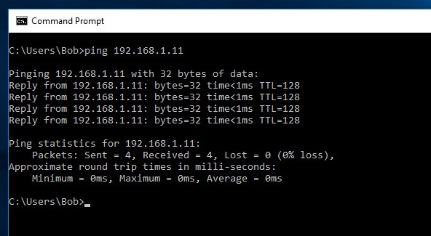

Were the ping results successful? ______________________

If not, there is good chance that **Windows Firewall** is blocking ICMP echo requests (ping). Click **Start** > **Settings** > **Network & Internet** > **Ethernet** > **Windows Firewall** to turn it off.

**Note**: If you did not get a reply from PC-B, try to ping PC-B again. If you still do not get a reply from PC-B, try to ping PC-A from PC-B. If you are unable to get a reply from the remote PC, ask your instructor to help you troubleshoot the problem.